Census of India Data Analysis Report

**Introduction:**

The "Census of India Data Analysis Report" presents a comprehensive examination of demographic and socioeconomic data collected during the Census of India project. This project aimed to extract valuable insights from two primary data sources: Data1 and Data2, utilizing structured query language (SQL) commands for data analysis.

* **Overview:**

The Census of India is a massive national undertaking that collects and records demographic information on the country's population. This data serves as a critical foundation for understanding India's societal dynamics, guiding policy decisions, and evaluating progress towards developmental goals. In this analysis, we delve into the Census data to uncover trends, disparities, and essential indicators that can inform policy and decision-making.

* **Data Sources:**

*Data1*: This dataset comprises a wide range of demographic and socioeconomic variables, including information on states, districts, growth rates, sex ratios, literacy rates, and more.

*Data2*: This dataset provides additional details, primarily focusing on population figures for various regions and districts.

* **SQL Commands for Data Analysis:**

The analysis in this report leverages SQL commands to extract, transform, and analyze data from these datasets. SQL offers a powerful toolset for querying and manipulating structured data, allowing us to derive meaningful insights and generate informative visualizations.

Throughout this report, we will present the SQL commands used to perform data extraction, aggregation, and analysis. These commands are instrumental in generating the statistics, summaries, and visualizations that underpin our findings and conclusions.

In the subsequent sections, we will delve into specific aspects of the Census data, including demographic profiles, state-wise analysis, socioeconomic indicators, gender disparities, and literacy rates. Each section will showcase the SQL commands employed to derive insights, providing a transparent and reproducible approach to our data analysis.

The goal of this report is to provide a thorough exploration of the Census of India data, shedding light on key trends and patterns that can inform decisions related to policy, development, and resource allocation.

**Analysis:**

1. **States Names Starting with letter 'A' :**

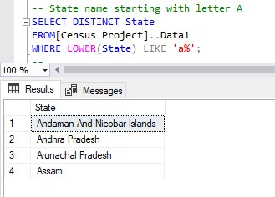

1. **States name Starting with 'A' or 'B':**

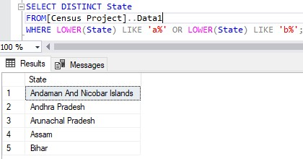

1. **States names Starting with 'A' or Ending with 'D':**

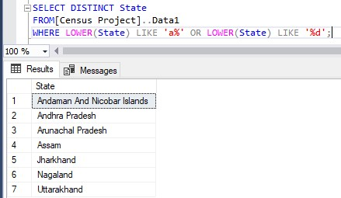

1. **Total Population of India:**

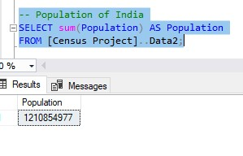

1. **Average Growth rate of India:**

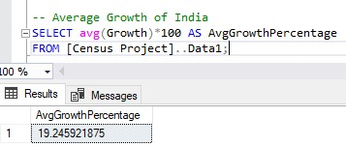

1. **Average growth rate by state.**

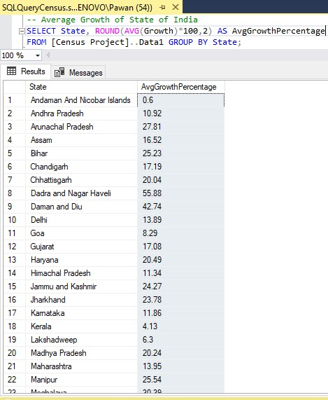

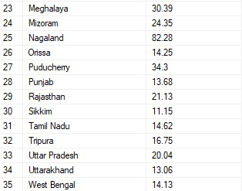

1. **Top Three States with Highest Growth rates:**

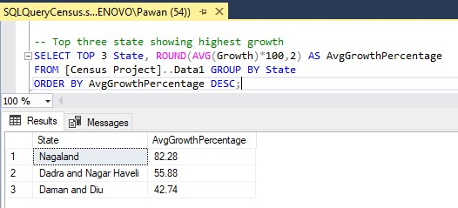

1. **Lowest Three States of Growth rates:**

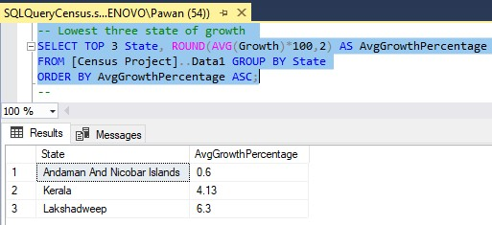

1. **Average Sex Ratio by State:**

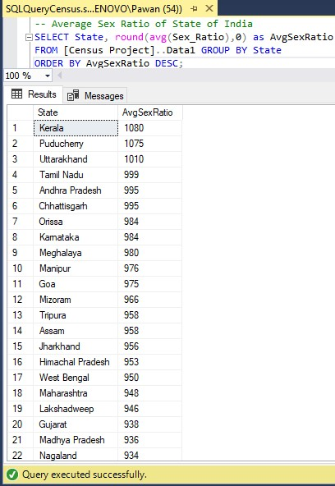

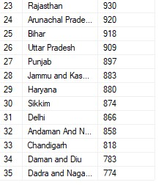

1. **Lowest Three States by Sex Ratio:**

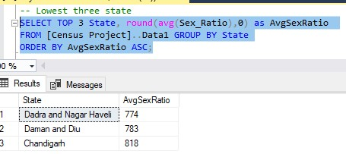

1. **Average Literacy Rate by State:**

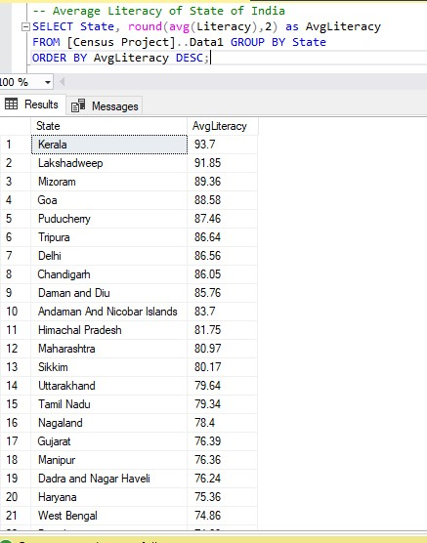

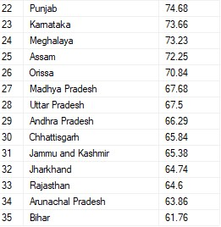

1. **States with Literacy Rate > 90%:**

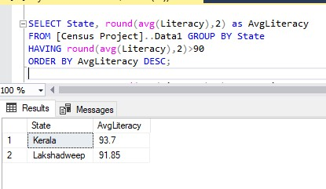

1. **Top Three and Bottom Three States by Literacy Rate:**

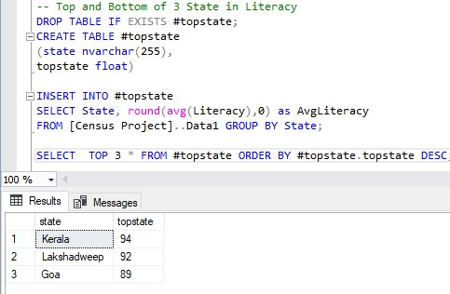

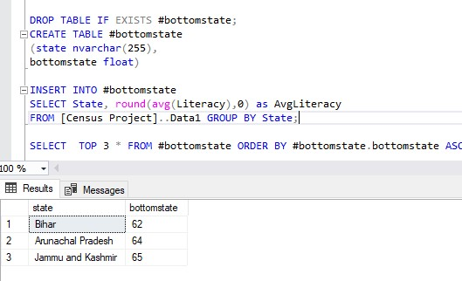

1. **Population, male, and female statistics by district and state**

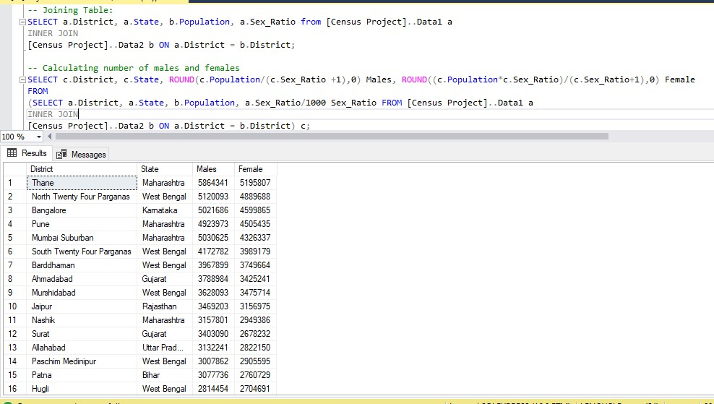

1. **Total Male and Female Population by State:**

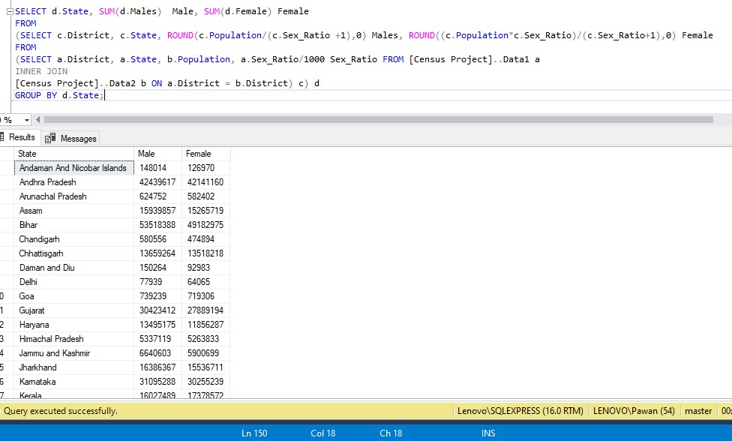

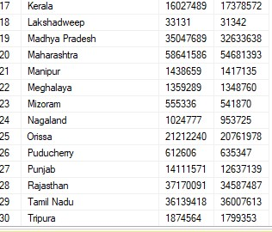

1. **Total literacy rate, literate, and illiterate populations by district and state.**

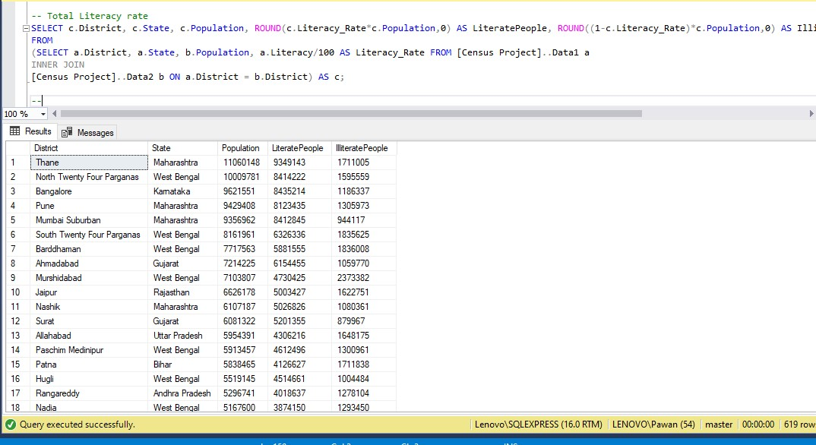

1. **Total literacy rate by state.**

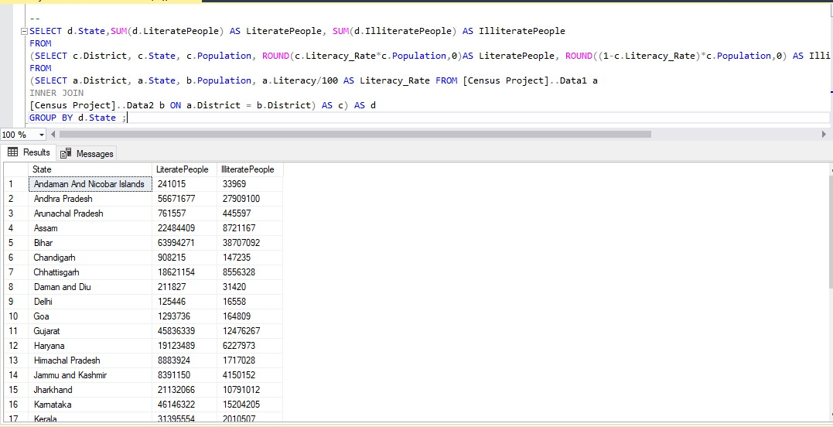

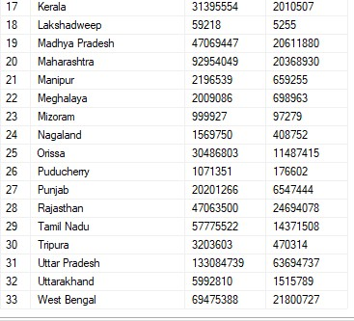

**Conclusion:**

The analysis of the Census of India data has yielded several key findings and insights. The data reveals significant variations in population growth, demographic attributes, and socio-economic indicators across different states of India. Notable findings include:

* India's population continues to grow, with certain states exhibiting exceptionally high growth rates such as Nagaland, Dadar and Daman, while others face challenges related to low growth Such as Andaman, Kerala, Lakshadweep.
* Demographically, there are variations in sex ratios, literacy rates, and growth rates among states, which offer valuable insights into the socio-economic landscape.

Like Sex ratio of Bihar 0.918 which is decent and literacy rates is 62% which is lowest in india while growth rate is 25.23%

* State comparisons highlight the diversity and unique characteristics of each region, each facing its own set of challenges and opportunities.
* These demographic and growth trends have wide-ranging implications for social and economic development in India, calling for targeted policy measures and interventions.

Based on these findings, we recommend a focused approach to address the specific needs of states with low growth rates and educational disparities. Additionally, continued data collection and analysis are essential to inform evidence-based policies and monitor progress in addressing demographic and socio-economic challenges.

In closing, the Census of India data serves as a critical resource for understanding the nation's dynamics and making informed decisions for the betterment of its diverse regions. Data analysis remains an essential tool in shaping the future of India's demographic and socio-economic landscape.